Connor Perron

BCS426

Prof. Aydin

Spring 2021

**Question 1: Write a C# .NET Core Console App that asks the user to enter a character and line number and then displays a triangle of that size with the given character. For example, if the user entered * as a character and 3 as line number then you display the following triangle on the console window.**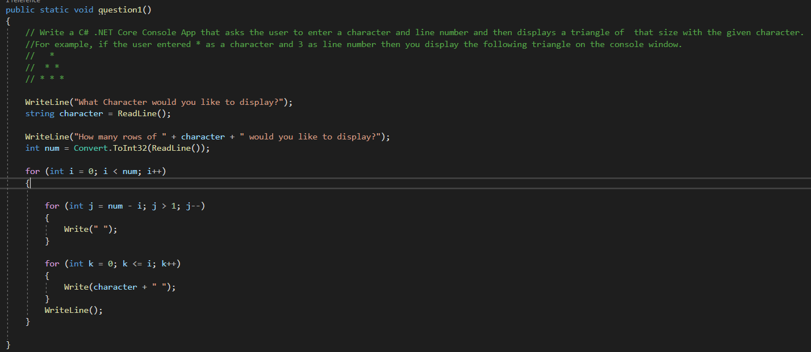

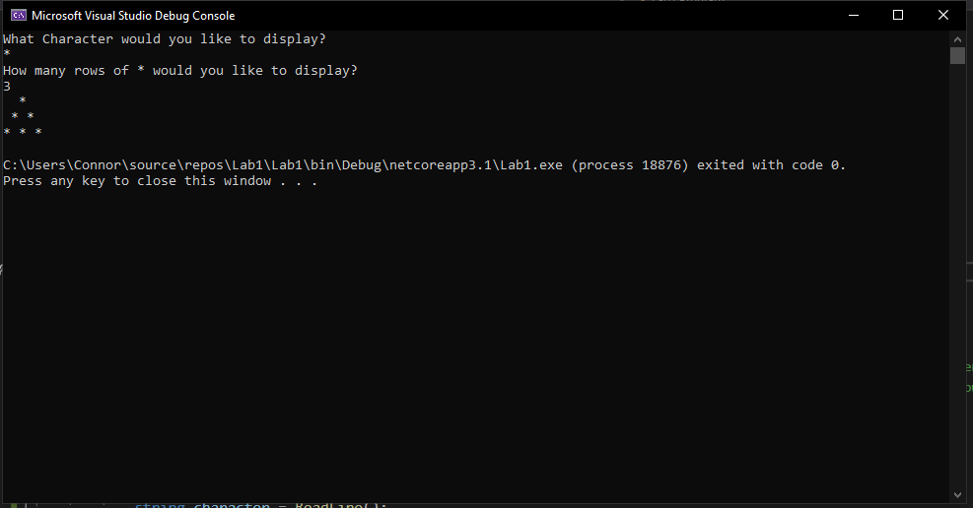

**Question 2: Modify your program above to display a diamond shape rather than a triangle. For example, if the user entered * as a character and 3 as line number then you display the following diamond on the console window.**

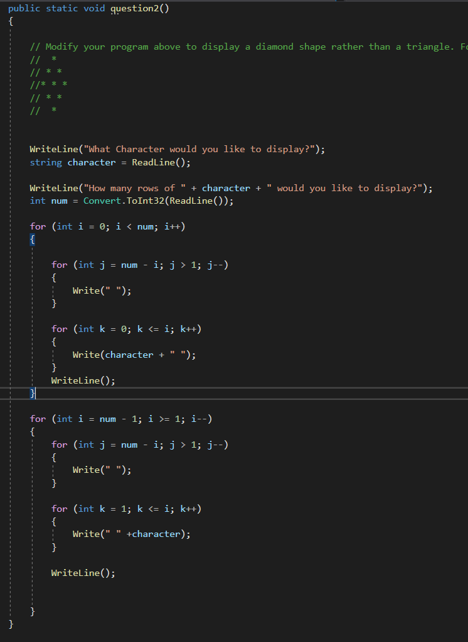

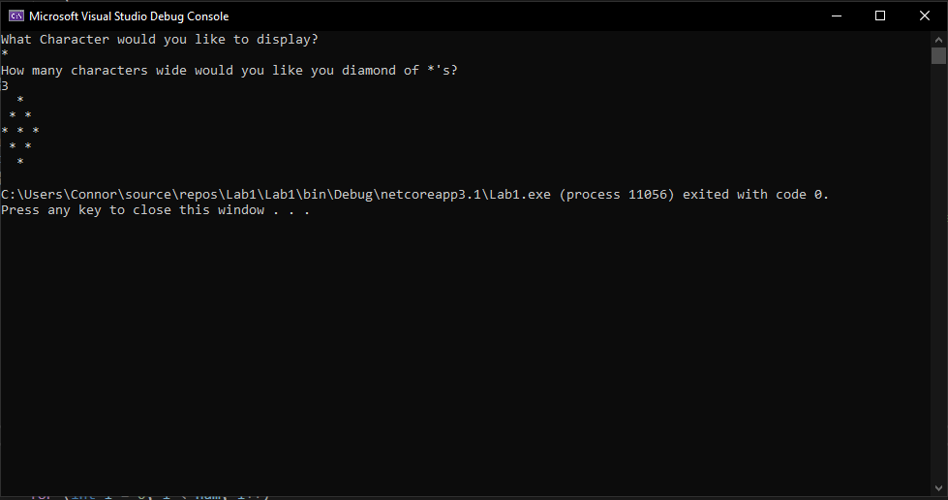

**Question 3: (3) Write a C# .NET Core Console App that asks the user to enter a number and then displays a string with the original number followed by the reverse of the number. For example, if the user entered 123 as an int you program should create a string "123321" and display it on the screen**

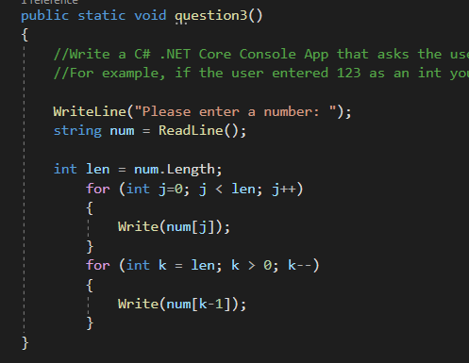

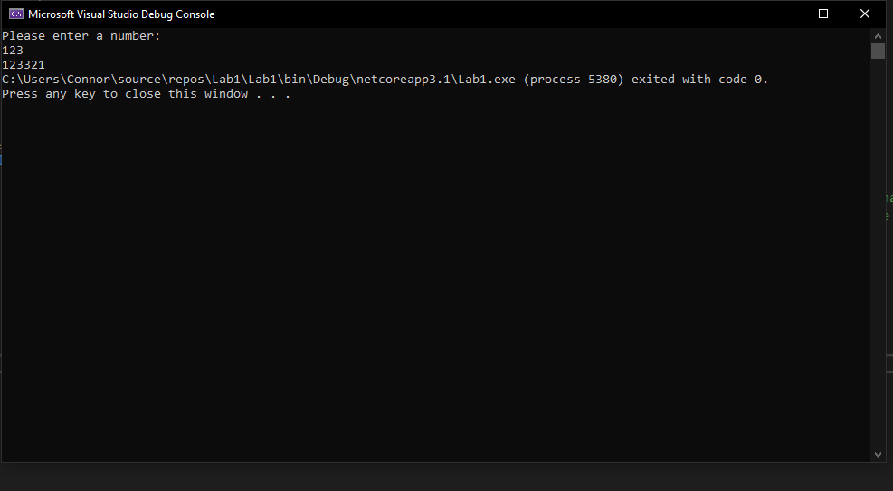

**Question 4: Write a C# Core Console App that validates a password string entered by the user to conform to the following rules:**

* **Length between 6 and 15 characters.**
* **At least one uppercase letter (A-Z).**
* **At least one lowercase letter (a-z).**
* **At least one digit (0-9).**
* **At least one supported special character such as ! @ # $ % ^ & * ( ) + = _ - { } [ ] : ; " ' ? < > , .**

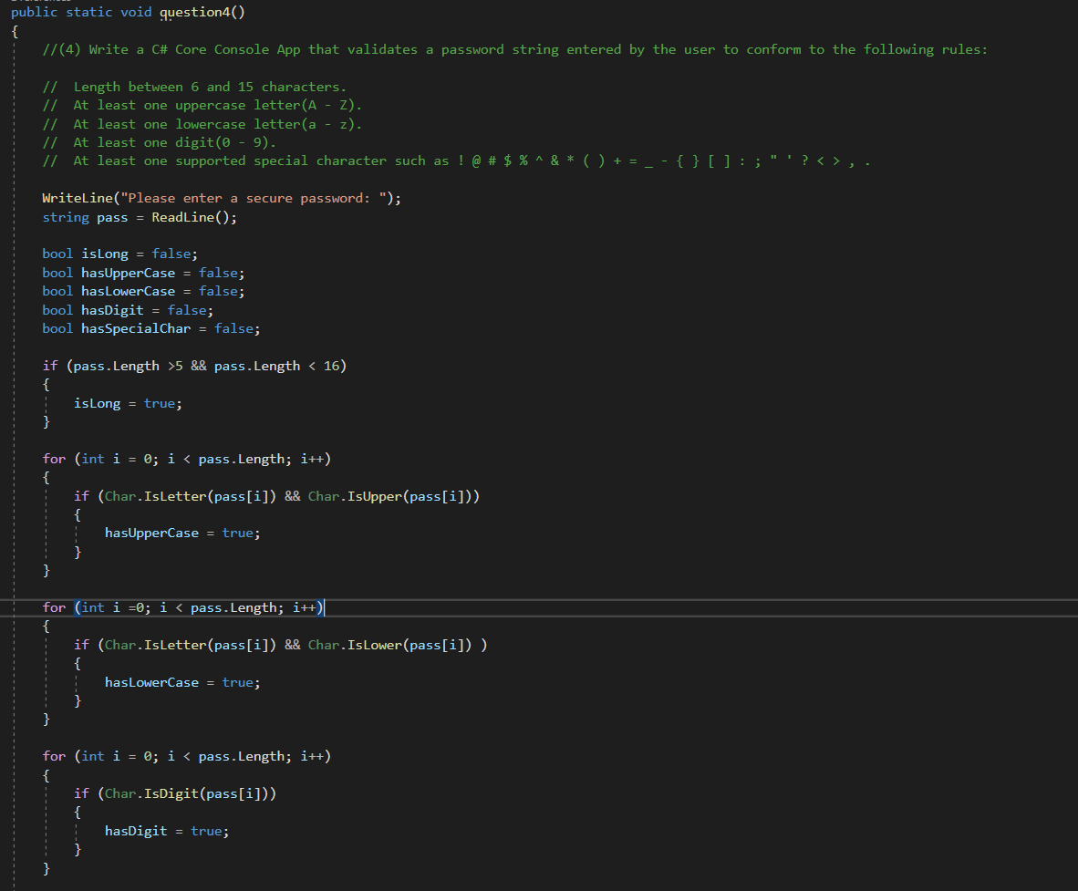

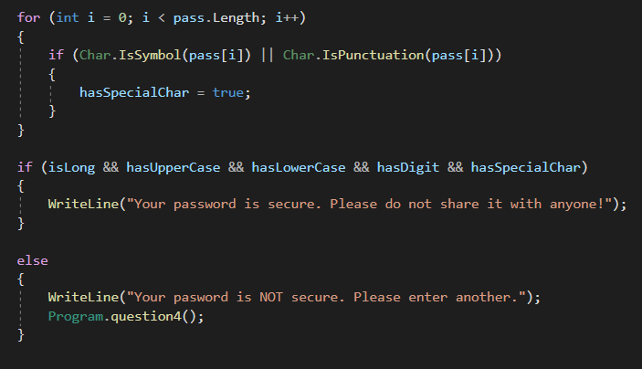

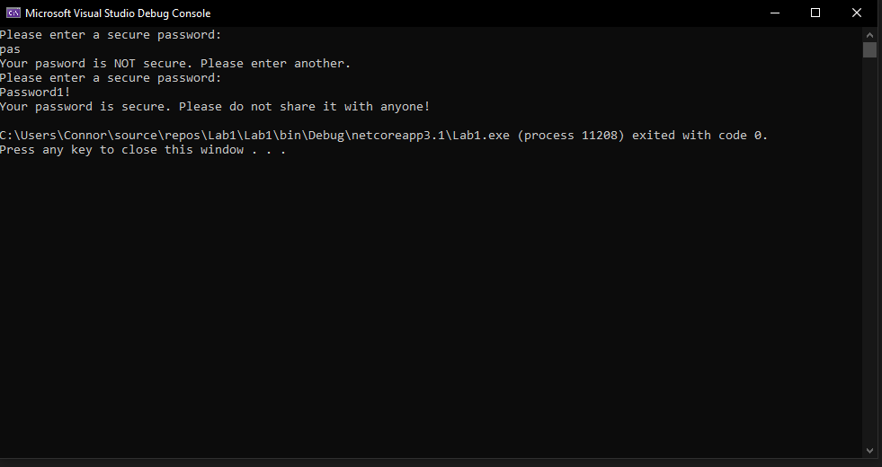

**Question 5: Comment about this lab and how easy/hard/appropriate you found it for this course as a first lab.**

I felt as though this lab was more than fair for a 400-level class. It allowed us to refresh basic skills such as input/output as well as logic. Since this language is new to many, it allowed us to research new functions and structures within the language while guiding our learning toward the curriculum.